 | MEASURED ENTITY
Company Name  Trade Name Location  Registration Number  VAT Number SDL Number  Certificate Number | JSE Limited  JSE Limited  One Exchange Square  2 Gwen Lane, Sandown, Sandton  2196  2005/022939/06  4080119391  L590719953  JSE000215-REV10
 | B-BBEE SCORE PER ELEMENT
Equity Ownership  Management Control  Skills Development  Procurement Enterprise & Supplier Development  Socio-Economic Development & Consumer Education  Empowerment Financing  Access to Financial Services  Additional Y.E.S points  Total Score  Final Score (converted) |  | 15.38  17.02 14.58  34.89  8.00  N/A  N/A  0.00  89.87  95.10
B-BBEE STATUS

AQRate (Pty) Ltd (Reg no. 2002/001364/07) | 1st Floor Acorn House, Old Oak Office Park, c/o Old Oak & Durban Roads, Bellville, 7530 | Tel: 086 12 77 283 | www.aQrate.co.za
Final B-BBEE Status Level Two Contributor
Final B-BBEE Recognition Level 125%
Empowering Supplier Yes
Discounting Principle Applied to final level No
Participation in Y.E.S and tier achieved N/A
Level & Points from Y.E.S. Initiative No additional levels or points
Exclusion Principle applied to Ownership No
Modified Flow-Through Principle Applied No
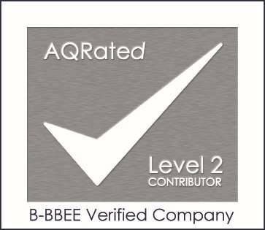
Black Ownership Flow-Through Modified Flow-Through
Voting Rights of Black People 18.76% N/A Voting Rights of Black Women 7.30% N/A Economic Interest of Black People 12.49% N/A Economic Interest of Black Women 4.60% N/A
51% Black Owned No
30% Black Women Owned No
51% Black Designated Group Supplier No
Black Youth 2.50%
Black Disabled People 0.00%
Black Unemployed People 0.00%
Black People living in rural/under-developed areas 0.00%
Black Military Veterans 0.00%
Measurement Period Financial Year Ended 31 December 2020
Amended Financial Sector Generic Scorecard:
Applicable Scorecard
Stock Exchanges or Members of Stock Exchanges
Applicable BEE Code Gazetted Codes 41287
Issue Date 19 February 2021
Original Issue Date N/A
Expiry Date 18 February 2022


William Smith
BVA021
Technical Signatory
AQRate has assessed and verified the relevant B-BBEE Elements of the above mentioned enterprise, to provide an independent and impartial opinion on the B-BBEE status of the enterprise, based on the Amended Financial Services Charter Sector Code (FS000 - FS800), in line with the Broad-Based BEE Codes of Good Practice (Codes 000-600), as amended.

