Equity Market:
Direct Market Access Questionnaire

Member Name:
Date of Application:
Submitted By:

Date:

Contents

2.1 Definition of an Order Entry Application (OEA) 3
2.2 Definition of Direct Market Access (DMA) 3
5.1 Avoidance of Erroneous Orders and Manipulative Practices 6
5.2 Management of orders; Order Limits; and Order Types 7
5.3 Management of Hidden Orders 8
5.4 Settlement Assurance 9
5.5 Adherence to Trading Sessions 10
5.6 Adherence to Security and Technical Requirements 10
5.7 Maintenance of Audit Trails 11
5.8 Adherence to JSE Rules and Directives 11

1 | Introduction
To ensure that JSE members promote market integrity and adequately manage their risk in conducting their trading activities, each Trading Services Provider (TSP) that wishes to implement an Order Entry Application (OEA) that provides Direct Market Access (DMA) to the member’s clients is required to meet certain criteria regarding the operation of such systems in terms of Directives BT 9 and BT 10.

The purpose of this questionnaire is to enable the JSE to gain a clear understanding of how the application will be operated and controlled and to obtain assurance from the member that the operation of the application will not negatively impact on the integrity of the market and will facilitate effective risk management of orders processed by the application. The response submitted by the member to this questionnaire will assist the JSE in assessing whether the member’s OEA appears to meet the key objectives set out in Directive BT 10.

- | Definitions
  - Definition of an Order Entry Application (OEA)
The JSE rules define an OEA as follows:

“Order entry application” means any system, software or program operated by a member which facilitates electronic submission of orders to a member trading application, and which complies with such requirements as the JSE may from time to time prescribe in the directives.

  - Definition of Direct Market Access (DMA)
The JSE rules define DMA as follows:

“Direct market access” means the process whereby an order is received electronically by a TSP and then submitted electronically to the JSE equities trading system by means of an order entry application operated by the TSP, without the intervention of a registered securities trader.

- | Requirements for an OEA that facilitates DMA
The requirements applicable to the operation of an OEA that provides DMA are contained in Directives BT 9 and BT 10 which state the following:

“BT 9 - A TSP shall not operate an Order Entry Application that provides Direct Market Access (“DMA”) without the prior written approval of the JSE. The approval when granted will be for the use of an OEA by the member to facilitate the electronic submission of orders and shall be on the condition that the member ensures at all times that the OEA meets the key objectives set out in BT 10. The JSE may at any time review and withdraw such approval.

BT 10 - A member applying to operate an OEA that provides DMA must be able to demonstrate, to the satisfaction of the JSE, that the OEA meets all of the following key objectives:

10.1 Avoidance of Erroneous Orders and Manipulative Practices
The OEA must ensure that orders are not submitted to the JSE equities trading system or left open in the JSE equities trading system where such orders could result in erroneous trades, a false appearance of trading activity or an artificial price for an instrument.

10.2 Management of Order Limits and Order Types
Adequate controls should be implemented to ensure that orders are within the normal trading patterns of the relevant clients. The OEA should also be able to limit the life of an order and be able to control each of the relevant order types.

10.3 Settlement Assurance
The OEA must be able to verify, before submitting any orders to the JSE equities trading system, the capacity of the client/member to settle trades resulting from orders processed via the application, through the use of appropriate exposure limits for non-controlled clients and checks on availability of funds and securities for controlled clients.

10.4 Adherence to Trading Phases
The OEA must be able to detect and react to the various JSE defined trading sessions.

10.5 Maintenance of Audit Trails
The OEA must be able to identify the source of all order details submitted to the JSE equities trading system and must ensure and be able to evidence the maintenance of the integrity of the order details from the receipt thereof by the member to the submission of the order to the JSE equities trading system.

10.6 Adherence to JSE Rules and Directives
All orders submitted to the JSE equities trading system by the OEA and the trades resulting from those orders must comply with the requirements of the rules and directives.

10.7 Adherence to security and technical requirements
The technical specifications of the OEA must comply with the JSE Users Specification Documentation and must ensure that the operation of the application will not adversely impact the operation of the market. Access to the application software and the data utilised by that software must be strictly controlled to prevent undue manipulation.

An application to the JSE to operate an OEA that provides DMA shall be in the form prescribed by the JSE from time to time.”

It should also be noted that in terms of rule 6.10.11, the Market Controller may instruct a member to immediately discontinue using a member or client application or may restrict the usage by a member of any or all components of a member or client application. This action would be considered in circumstances where the JSE is of the view that the OEA is not meeting one or more of the key objectives set out in Directive BT 10.

It is also important to note that in terms of Directive BT13, a member must ensure that the JSE allocates one or more trader identification numbers to the member in respect of an OEA that provides DMA which will facilitate the identification of orders processed by the OEA as being DMA orders.

- | Application for the use of an OEA that facilitates DMA
In utilising an OEA that facilitates DMA, the measures that a member would apply to assure settlement of transactions by controlled clients are materially different to those that would be applied in respect of transactions by non-controlled clients. For controlled clients and own accounts, the OEA should be able to confirm the availability of funds or securities, whereas for non-controlled clients the member would instead set credit or trading limits which would be maintained within the system.

In recognition of the different control measures that would be applied by a member in utilising an OEA for controlled clients versus non-controlled clients, the JSE requires a member applying to implement an OEA that facilitates DMA to indicate in their application whether the OEA is to be utilised for controlled clients or non-controlled clients, or both.

If the member is only intending to utilise the OEA for one of the two categories of clients, the approval, when granted, will only be in respect of that category of clients. If the member subsequently wishes to utilise the OEA for the other category of clients, they will be required to submit a separate application. The separate application will enable the JSE to assess whether the member has implemented adequate measures in utilising the OEA to assure settlement of transactions by the other category of clients.

If a separate application is subsequently submitted for the use of an OEA that facilitates DMA in respect of another category of clients, the member will only need to respond to those questions in the Settlement Assurance section of the questionnaire which relate specifically to that category of clients.

- | Information Required
The member is required to answer the questions below to indicate how the required objectives will be met in the operation of the OEA.

  - Avoidance of Erroneous Orders and Manipulative Practices

5.1.1 | What will the DMA be used for? And how do you see this DMA working?
5.1.2 | A volatility auction is triggered when a projected trade price is more than a defined percentage away from the static and dynamic reference prices. The percentages are currently defined as follows:  ZA01  Trading Session Static Circuit Breaker % Dynamic Circuit Breaker %  Continuous Trading 10% 3%  Closing Auction Call 8% 6%  Opening Auction Call 8% 6%  Reopening Auction Call 8% 6%  FCO Auction Call 15% 2%  Volatility Auction Call 8% 3%  ZA02  Trading Session Static Circuit Breaker % Dynamic Circuit Breaker %  Continuous Trading 15% 5%  Closing Auction Call 20% 10%  Opening Auction Call 20% 10%  Reopening Auction Call 20% 10%  FCO Auction Call 30% 4%  Volatility Auction Call 20% 10%  How does the application ensure that unnecessary volatility auction call sessions are not triggered?
5.1.3 | How are the limits set for orders in terms of price movement, volume and value applied in segments ZA03, ZA04 and ZA06 given the fact that there are no circuit breakers defined in these segments?
5.1.4 | How does the member ensure that the price of the order is within a defined parameter of the static and dynamic reference prices?
5.1.5 | Reported transactions may not be submitted through the application as its sole purpose is to facilitate automatic ORDER routing. How does the application prevent the submission of reported transactions to the trading system?
5.1.6 | How is the application started up in the morning and how are prices maintained throughout the day? Please supply graphical illustrations.
5.1.7 | What happens to the open orders if an instrument is halted?
5.1.8 | What happens to the open orders if an instrument is suspended?
5.1.9 | How will corporate actions, which may affect prices, be handled on open orders?
5.1.10 | Are there training programs for users (including clients) who use the Order Entry Application? Provide an overview of this training.
5.1.11 | How is the expiry of orders handled and how are clients notified?

  - Management of orders; Order Limits; and Order Types

5.2.1 | What are the general system limits for orders in terms of volume and value? Are they in line with the minimum reserve size (MRS) defined by the JSE for each instrument? How is this controlled?
5.2.2 | Will the application allow for all of the 11Time in Force (TIF) validity types? (DAY, OPG, GFA, GFX, GTD, GTC, ATC, FOK, IOC, GTT and CPX) If yes, what application control parameters are used?
5.2.3 | Please specify the instrument types for which orders will be placed through the application e.g. Warrants, Krugerrands etc.
5.2.4 | What is the life of the orders that will be placed through this application?
5.2.5 | What processes are in place to ensure that orders routed through the application fall within the normal trading pattern for the client, based on established client profiles relating to normal trading values, type of instruments traded etc.?
5.2.6 | As per directive BT4.3. In the event that the connectivity is interrupted between the member and a direct market access client or if the members trading application which generates proprietary trades is unable to interact with the JSE trading system, the TSP must have the ability to cancel or modify any orders submitted to the JSE trading system by the direct market access client or the member trading application. Please confirm that the relevant procedures and processes are in place to facilitate this?

  - Management of Hidden Orders
Hidden Limit orders allow participants to enter limit orders on to the order book without displaying either the price or volume to other participants. Hidden orders are able to interact with both displayed orders and other hidden orders in the central order book.
Therefore, in summary, hidden orders MUST:
- Be large in scale
- Meet the Minimum Reserve Size (MRS) to qualify as hidden
- Specify a Minimum Execution Size (MES) that is equal to or greater than MRS
Hidden orders MUST NOT:
- Be entered or amended during auction periods

5.3.1 | Will Hidden Limit Orders be submitted through this application?
5.3.2 | Hidden Orders where the Order Quantity is less than the MRS may not be entered. How will the user be prevented from submitting an order that does not meet this requirement?
5.3.3 | MES is a mandatory field when entering hidden orders and must be equal to or greater than MRS. The JSE will reject any order submissions where the MES<MRS How will this be adhered to?
5.3.4 | When a hidden order is partially filled and the remaining quantity is less than the specified MRS and MES, the order will be automatically expired by the JSE. How will this be managed?
5.3.5 | Hidden Orders cannot be entered or amended during auction call periods. How is this controlled?
5.3.6 | Hidden Orders that do not meet the specified MRS consideration value upon entry or modification of the order will be rejected. How will the application prevent such orders from being submitted to the trading engine?

  - Settlement Assurance

5.4.1 | Is the application going to be utilised to facilitate the electronic submission of orders for own account, controlled clients or non-controlled clients, or all three?

Controlled Clients
5.4.2 | How is the availability of cash and scrip checked for controlled client orders? How is this check applied to multiple orders per client?

Non- Controlled Clients
5.4.3 | What type of pre-settlement exposure limits are set for non-controlled clients e.g. individual order limits, daily trading limits, aggregate settlement exposure limits?
5.4.4 | How are the relevant pre-settlement exposure limits for each non-controlled client determined?
5.4.5 | If limits other than aggregate settlement exposure limits (e.g. order limits) are set for non-controlled clients, how does the member and/or the application ensure that the aggregate settlement exposure for each non-controlled client is still within reasonable limits?
5.4.6 | Who approves the exposure limits?
5.4.7 | Explain the process whereby exposure limits are approved or amended prior to the limits being recorded in the system.
5.4.8 | How is access to the exposure limits in the system controlled?
5.4.9 | If aggregate settlement exposure limits are used, explain how each non-controlled client’s aggregate settlement exposures at the beginning of each day are recorded in the system.
5.4.10 | How often are the exposure limits recorded in the system reviewed to ensure that they are still relevant and have not been amended without the necessary authority?

  - Adherence to Trading Sessions

5.5.1 | Is the application designed to detect and react to price monitoring and market order extensions? What alerts are raised if these conditions occur and who receives the alerts?
5.5.2 | In which functional segments will the member make use of the application? If across multiple functional segments, how are the various trading rules and related changes managed e.g. Trading Phases?
5.5.3 | How does the application detect and react to various market trading schedules e.g trading halts?

  - Adherence to Security and Technical Requirements

5.6.1 | How is user access to the OEA maintained?
5.6.2 | What security has been implemented to ensure confidentiality and authentication of member and client data?
5.6.3 | Where is the physical server to which the application connects, housed?
5.6.4 | What is the capacity of the line used to access the application?
5.6.5 | How many orders will be submitted through the application at any point in time (maximum message rate)?
5.6.6 | Are the above limits configurable? Please state whether they are static or dynamic.
5.6.7 | What is the communication protocol used by the OEA? Who is responsible for managing and maintaining it?
5.6.8 | Define all system parameters and indicate who is responsible for maintaining these. Include security and access controls where necessary.
5.6.9 | No changes can be made to the OEA unless the JSE has been notified, in writing, of any proposed changes and they have been subsequently approved by the JSE. What version control procedures are in place?

  - Maintenance of Audit Trails

5.7.1 | How will the member identify the source of order details? Is the member able to supply these to the JSE as and when required?
5.7.2 | How does the member track and record any system parameter changes?
5.7.3 | How will the member be able to ensure and evidence that the order details received electronically from a client are the same as those submitted to the trading system via the OEA?

  - Adherence to JSE Rules and Directives

5.8.1 | What pre-validation checks are performed on order parameters e.g. Instrument ID, ISIN, status of the instrument, price, etc.?
5.8.2 | The Market Controller may restrict the usage by a TSP of any or all components of a member or client application. Can the application be “switched off” without impacting any other applications within the member’s office? Describe the process.
5.8.3 | Are there in-house training programs for employees of the member who use the Order Entry Application? Provide an overview of this training.
5.8.4 | If the member is only permitted to utilise the OEA for the purpose of processing orders submitted by one category of clients (own account, controlled or non-controlled), how will the member prevent orders from being submitted and processed in respect of the other category of clients?

- | Evaluation and Approval Process
For all applications, the evaluation and approval timeline is 10 working days. If the submitted documentation is incomplete, the JSE will request the member to resubmit the application and the approval process will restart from the date of resubmission.

OEA Approval Process
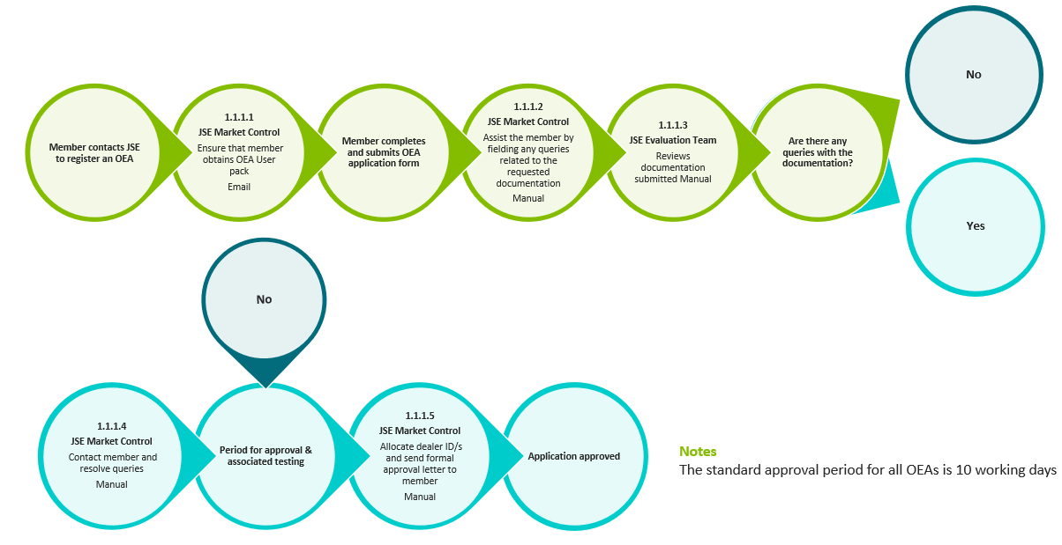

- | Additional information to be submitted by members
In terms of Directive BT 11, the JSE may request information from members regarding their use of OEAs that facilitate DMA in order to monitor the extent of usage of such systems and to assess the appropriateness of the measures implemented by members to control the use of such systems on an ongoing basis.

- | JSE Contact Details

Department | Contact Number | Email
Customer Support | +27 (11) 520 7777 | Customersupport@jse.co.za
EDM (Technical) | +27 (11) 520 7580 | Wesleyk@jse.co.za

